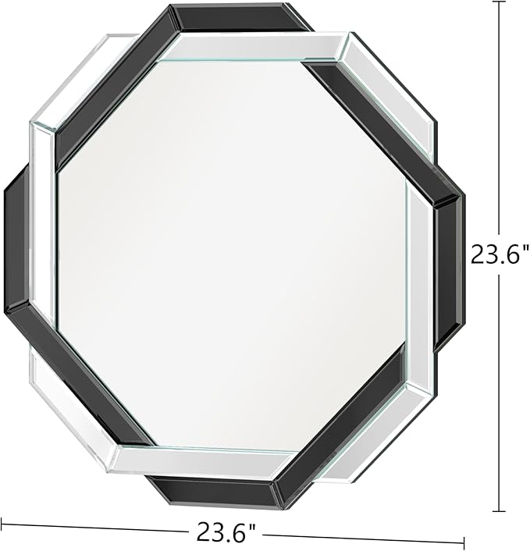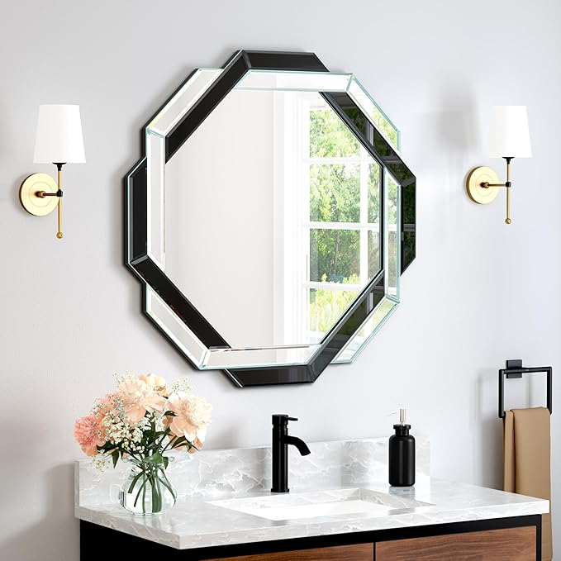

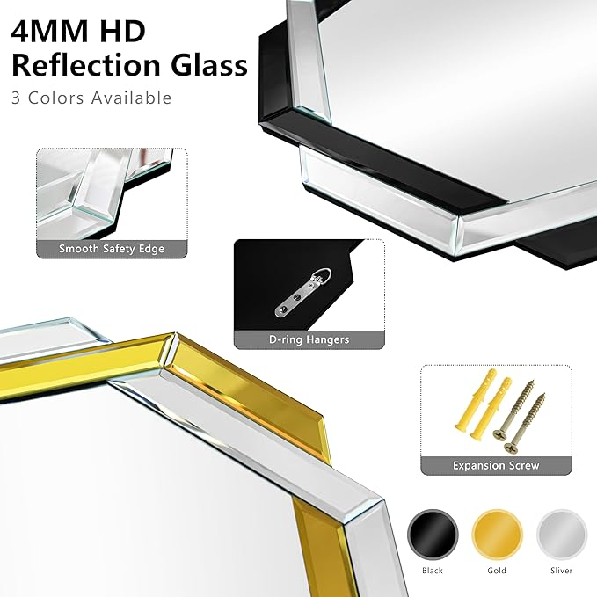

Decorative, Beveled Edge Frameless Mirror for Wall Bathroom, Vanity Room, Bedroom, Living Room and Enterway

**PRODUCT DESCRIPTION:**

|  |  |
| --- | --- |
| Brand | Menscha |
| Room Type | Bathroom |
| Shape | Round |
| Product Dimensions | 24"L x 24"W |
| Frame Material | Glass |

**About this item**

* SPECIAL DESIGN: With statement-making to clean-lined accents, offers sleek. Classic, frameless, beveled edges.Sleek wall mirror is a not only bathroom mirror, also be an adornment, making a personalized statement over any bathroom vanity, powder room or on any wall
* EASY TO INSTALL: Our silver mirror comes with safety polished edges for protection and a finished appearance, glass is securely mounted to solid core wood, all mirrors come with reinforced mounting brackets as well as wall hardware and screws to hang horizontally or vertically
* HIGH QUALITY: All decorative mirror use high-end 4mm thick silver glass mirror, which provides a clear distortion-free reflection, and eliminate the common reflective distortion of low-end mirrors. The mirror's clear image gives you the best visual experience
* SAFETY PACKAGING: Packaging includes all-around protective Styrofoam box, embedded foam boards in different sizes and thick corrugated outer box. All mirrors in our store have passed all tests, including heavy pressure test, impact test, drop test and so on
* CUSTOMER SERVICE: We value our customer and commit customer service will be respond within 24 hours. If you have any questions, please feel free to contact us, we will solve it for you as soon as possible